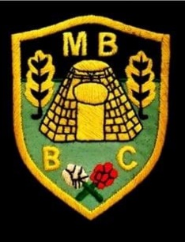

Market Bosworth Bowling Club

League Match Results

|  |  |  |  |  |
| --- | --- | --- | --- | --- |
| **Hinckley League – Monday Night (C Team)** | | | | |
| Fixture: | | | Overall Score: | Result |
| Lutterworth B | Vs | Market Bosworth C | 41-53 | WON |
| Market Bosworth C | Vs | Shakespeare Park | 36-71 | LOST |
| Market Bosworth C | Vs | Hinckley A | 37-81 | LOST |
| Countesthorpe C | Vs | Market Bosworth C | 42-64 | WON |
| Market Bosworth C | Vs | Burgess A | 53-44 | WON |
| Ambleside B | Vs | Market Bosworth C | 33-66 | WON |
| Market Bosworth C | Vs | Barwell B | 46-50 | LOST |
| Market Bosworth C | Vs | Lutterworth B | 54-44 | WON |
| Shakespeare Park | Vs | Market Bosworth C | 41-52 | WON |
| Hinckley A | Vs | Market Bosworth C | 43-45 | WON |
| Market Bosworth C | Vs | Countesthorpe C | 24-28 | LOST |
| Burgess A | Vs | Market Bosworth C | 49-51 | WON |
| Market Bosworth C | Vs | Ambleside B | 83-32 | WON |
| Barwell B | Vs | Market Bosworth C | 12-55 | WON |

TEAM OVERALL WIN RATE OF SEASON- 72%