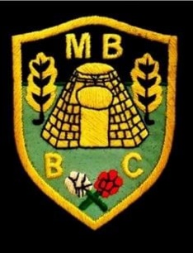

Market Bosworth Bowling Club

League Match Results

|  |  |  |  |  |
| --- | --- | --- | --- | --- |
| **Hinckley League – Monday Night (A Team)** | | | | |
| Fixture: | | | Overall Score: | Result |
| Market Bosworth A | Vs | Kingscroft D | 36-34 | WON |
| Hollycroft A | Vs | Market Bosworth A | 70-36 | LOST |
| Desford A | Vs | Market Bosworth A | 47-51 | WON |
| Market Bosworth A | Vs | Wycliffe A | 61-52 | WON |
| Kirby Muxloe A | Vs | Market Bosworth A | 47-46 | LOST |
| Market Bosworth A | Vs | Countesthorpe A | 35-50 | LOST |
| Bagworth | Vs | Market Bosworth A | 60-40 | LOST |
| Kingscroft D | Vs | Market Bosworth A | 56-50 | LOST |
| Market Bosworth A | Vs | Hollycroft A | 41-59 | LOST |
| Market Bosworth A | Vs | Desford A | 45-61 | LOST |
| Wycliffe A | Vs | Market Bosworth A | 46-54 | WON |
| Market Bosworth A | Vs | Kirby Muxloe A | 41-61 | LOST |
| Countesthorpe A | Vs | Market Bosworth A | 63-44 | LOST |
| Market Bosworth A | Vs | Bagworth | 30-45 | LOST |

TEAM OVERALL WIN RATE OF SEASON- 29%