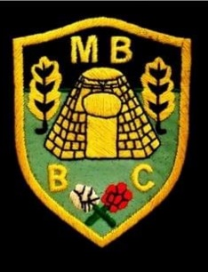

Market Bosworth Bowling Club

League Match Results

|  |  |  |  |  |
| --- | --- | --- | --- | --- |
| **Hinckley League – Monday Night (B Team)** | | | | |
| Fixture: | | | Overall Score: | Result |
| Market Bosworth B | Vs | Burgess B | 67-33 | WON |
| Hinckley C | Vs | Market Bosworth B | 59-51 | LOST |
| Market Bosworth B | Vs | Lutterworth A | 51-54 | LOST |
| Nuneaton A | Vs | Market Bosworth B | 54-29 | LOST |
| Market Bosworth B | Vs | Hollycroft B | 72-38 | WON |
| Market Bosworth B | Vs | Kingscroft C | 0-0 | ? |
| Burgess B | Vs | Market Bosworth B | 54-45 | LOST |
| Market Bosworth B | Vs | Hinckley C | 43-46 | LOST |
| Lutterworth A | Vs | Market Bosworth B | 41-47 | WON |
| Market Bosworth B | Vs | Nuneaton A | 53-14 | WON |
| Hollycroft B | Vs | Market Bosworth B | 49-37 | LOST |
| Kingscroft C | Vs | Market Bosworth B | 54-44 | LOST |

TEAM OVERALL WIN RATE OF SEASON- 30%